CASE:
A 30 year old man was referred to the endocrine clinic for evaluation of a possible pheochromocytoma.
The patient was evaluated in the emergency room for cough and dyspnea where a CT scan of the chest was performed to evaluate the patient for a possible pulmonary embolism. This revealed a right adrenal mass measuring 4.4 cm in its greatest dimension.

HISTORY:
The patient reported tachycardia and uncontrolled blood pressure (up to 145/112). Patient also reported weight loss, fatigue and anxiety. He denied chest pain, headaches, or dizziness.
He had no family history of adrenal problems, but a sibling and father are BRCA1 positive. There was also a paternal relative who died at age 22 of an unknown heart issue and who also had some features of Marfan’s syndrome (tall with long torso and long arms). The patient was seen by his local endocrinologist who ordered labs which demonstrated elevated plasma and urine normetanephrines. He was treated with phenoxybenzamine 10 mg twice daily.

PHYSICAL EXAM:
Vitals: Blood pressure 134/92, heart rate 122 bpm, respiratory rate 18 breaths/min, BMI 40.
Physical examination was unremarkable.

LABORATORY TESTING:
24-hour urine catecholamine plus VMA:
24-hour VMA 9.2 mg/24 hours (0.0-7.5 mg/24 hours)
24-hour urine epinephrine 5 mcg/24 hours (0-20 mcg/24 hours)
24-hour urine norepinephrine 205 mcg/24 hours (0-135 mcg/24 hours)
24-hour urine dopamine 350 mcg/24 hours (0-510 mcg/24 hours)

24-hour fractionated metanephrines:
24-hour urine normetanephrine: 1755 mcg/ 24 hours (110-553 mcg/24 hours)
24-hour urine metanephrine: 102 mcg/24 hours (58-276 mcg/24 hours)

Plasma catecholamines
Plasma norepinephrine 1233 pg/mL (0-874 pg/mL)
Plasma epinephrine 21 pg/mL normal (0-62 pg/mL)
Plasma dopamine <30 pg/mL normal (0-48 pg/mL)

Plasma fractionated metanephrine:
Plasma normetanephrine 493 pg/mL (0.0-107.7)
Plasma metanephrine 13.5 pg/mL normal

Plasma renin activity 2.922 ng/mL, hr (0.167-5.380 ng/mL, hr)
Aldosterone 4.3 ng/dL (0.0-30.0 ng/dL)
8am: ACTH 43.4 pg/mL (7.2-63.3 pg/mL), cortisol 9.0 mcg/dL (6.2-19.4 mcg/dL)
TSH 2.940 uIU/mL (0.450-4.500 uIU/mL), free T4 1.05 ng/dL (0.82-1.77 ng/dL)
CBC and CMP within normal limits
DHEAS 43 mcg/dL (280-640 mcg/dL)
Total Testosterone 234.02 ng/dL (249.00-836.00 ng/dL)

DIAGNOSTIC IMAGING:
MRI showed a 4.3 x 4.3 x 4.3 cm right adrenal mass slightly heterogeneous and hyperintense on T2 and hypointense on T1 with no signal dropout on the chemical shift or fat saturated sequences

CT non-contrast. HU28
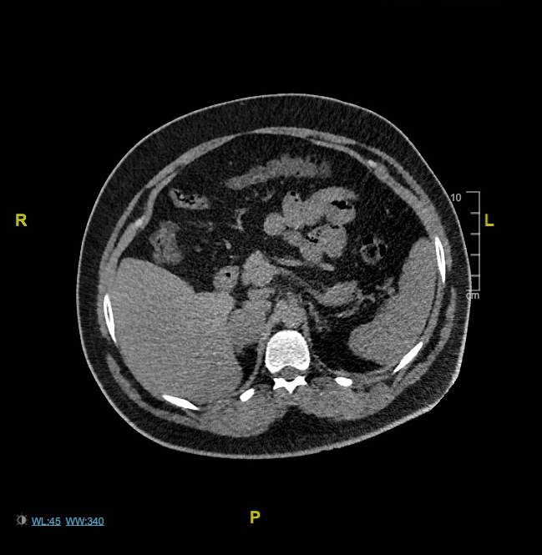

Contrast Images CT
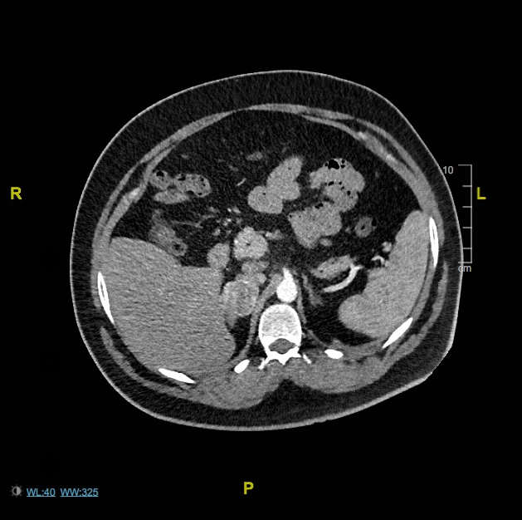

T2 MRI
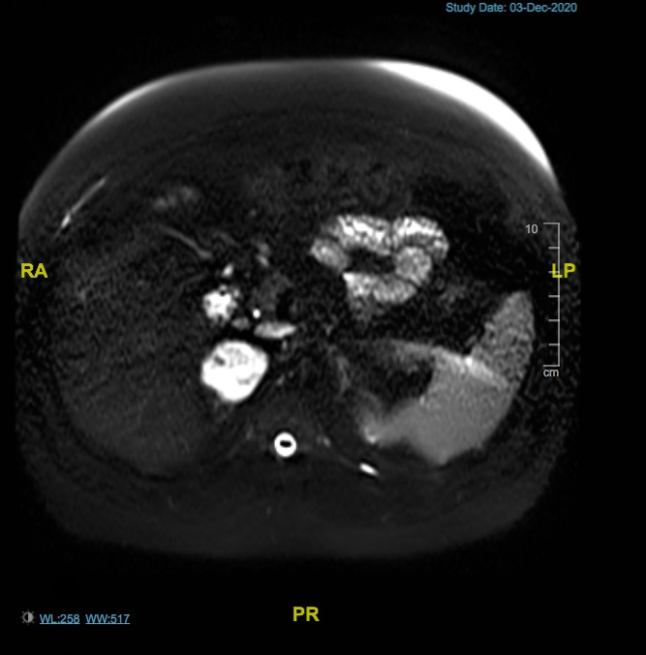

MANAGEMENT:
The patient was instructed to increase the phenoxybenzamine to 3 times daily. He was also asked to record orthostatic vital signs. These were reported to the clinic every 2 to 3 days for consideration of medication adjustment in order to maintain goal blood pressure and pulse. A beta-blocker was added preoperatively as well as salt and fluid load as his blood pressure control improved. The goal is for the patient to become orthostatic and have a blood pressure of less than 120/80. Patient was referred for surgical evaluation and underwent a right adrenalectomy. The planned procedure was laparoscopic but converted to open procedure due to extensive adhesions and scarring from prior cholecystectomy and neovascularity. The pathology demonstrated a 4.8 cm pheochromocytoma, completely resected. Post operatively, his blood pressure returned to normal. Laboratory evaluation 6 weeks post operatively revealed that the patient’s plasma fractionated metanephrines were normal: Plasma normetanephrine 0.76 nmol/L, plasma metanephrine <0.10 nmol/L The patient will return to the endocrine clinic in 6 months with repeat plasma fractionated metanephrines and MRI of the abdomen.
Patient was also seen by the genetics team and genetic testing revealed: Germline genetic mutation (pathogenic variant): BRCA1. Patient was also found to have RET VUS (variant of undetermined significance).
Genetics recommended baseline calcitonin, PTH and calcium levels to evaluate for MEN2. These laboratory tests will be performed and patient will follow up with our genetics team for further recommendations regarding the BRCA1 germline mutation.

DISCUSSION:
Pheochromocytomas and paragangliomas are rare tumors that originate in the adrenal medulla, sympathetic or parasympathetic ganglia.^{1,2} Most parasympathetic paragangliomas are found in the head and neck region, and those that originate from the sympathetic ganglia are found below the diaphragm in the chest, abdomen and pelvis.^{2,4} Pheochromocytomas and paragangliomas are tumors that are formed by an abnormal growth of chromaffin cells. Pheochromocytomas make up 80-85% of these tumors. Paragangliomas make up 15-20% of chromaffin cell tumors.⁵ Generally, these tumors secrete one or more catecholamines: epinephrine, norepinephrine, and/or dopamine. Less commonly, these tumors are biochemically silent.⁵ Patients with pheochromocytoma are at a high risk for cardiovascular complications such as myocardial infarction, stroke, arrhythmia than patients with essential hypertension. This makes diagnosis and treatment imperative.⁵ Management of these tumors is best accomplished using a multidisciplinary approach in centers where there are appropriate resources and specialists who are experienced in managing these tumors. This team includes specialists such as endocrinologists, surgeons, genetics, radiologists, medical oncologists, and radiation oncologists.
It is estimated that 0.1-0.6% of hypertensive adults will have a pheochromocytoma.⁶ There is a slightly higher incidence in women with a female to male ratio of 1.4:1.⁶ Symptoms of pheochromocytoma include hypertension, headache, palpitations, pallor, sweating, and anxiety. The presenting symptom most commonly seen with paragangliomas is pain or mass effect.² Other symptoms related to these tumors are nausea, flushing, and weight loss. In some cases, the patients may be asymptomatic.⁶ A biochemical evaluation for pheochromocytoma and/or paraganglioma is warranted if there are symptoms of over secretion (especially if symptoms are paroxysmal), the patient has an adrenal incidentaloma, there is known hereditary syndromes or genetic mutations associated with pheochromocytoma or paraganglioma, a previous history of disease, or symptoms brought on by certain medications such as anesthesia, beta blockers, or some psychotrophic medications.⁵ This evaluation should include plasma free metanephrines or urinary fractionated metanephrines (with 24 hour creatinine to ensure complete collection). Plasma free metanephrines are best measured with patient in supine position as drawing blood while a patient is in a seat position could result in falsely elevated results. If both the normetanephrine and metanephrine levels are elevated, there is a lower risk of a false positive result. There is also lower risk of false positive results if either the normetanephrine or metanephrine levels is elevated by 3 fold the upper limit of normal or greater.⁵ Many psychotrophic medications may cause a false positive screening test, but tr1cyclic antidepressants and cyclobenzaprine are the most common offenders. Of note, Head and neck paragangliomas are typically non-functional.¹
Once, biochemical evidence is established, imaging should be performed to localize the tumor(s). CT scan with contrast is recommended for initial tumor localization. On unenhanced CT, pheochromocytomas have Hounsfield units of >10.² MRI should be used in patients with metastatic disease or if a head and neck paraganglioma is suspected. On MRI, paraganglioma and pheochromocytoma tumors are hyperintense on T2 imaging. MRI is also the preferred imaging modality for follow up with pheochromocytoma and paraganglioma.¹Functional imaging with ¹²³I-metaiodobenzylguanidine (MIBG) scan is used for patients who will be treated with ¹³¹I-MIBG radiotherapy and considered in patients who are at increased risk for metastasis. If a patient has known metastatic disease, ¹⁸F-fluorodeoxyglucose positron emission tomography (¹⁸F-FDG PET/CT) is the ideal imaging modality.⁵ Newer subtypes of PET imaging, such as gallium DOTATATE PET scans are also often used.²
Surgical resection may be beneficial in stopping both hypersecretion of hormone as well as tumor enlargement, but this may not completely negate the risk of persistence or recurrence but offers the best chance for remission or cure. ¹ Genetic testing results, tumor size, BMI, and suspicion for malignancy play into the decision for the best surgical approach (laparoscopic versus open).¹ In tumors that are functional, blockade is recommended preoperatively. This is usually accomplished with a combination of α- and β- blockade with α-blockade always started first. α-adrenergic blockade should be used in patients with functional tumors 7-14 days prior to any surgery.⁵ This helps lower the risk of cardiovascular complications. These patients also need to follow a high sodium diet (5,000 mg/day) and a daily fluid intake of 2.5 L/day. The goal blood pressure pre op is less than 120/80 mmHg sitting with a heart rate of 60-70 bpm and above 80/45 mmHg standing with a pulse of 70-80 bpm. Sometimes a calcium channel blocker is also added. β-adrenergic blockage is initiated if the pulse increased above 100 bpm and only after the α-adrenergic blockade has been initiated.¹ Postoperatively, the patient needs to bemonitored closely for hypotension and or rebound hypoglycemia 24-48 hours after surgery. Cortical sparing surgery is sometimes considered in bilateral disease, especially if the probability of malignancy is low, for example, in patients with VHL or MEN2. This is to prevent post op adrenal insufficiency.⁵ The risk of recurrence increased in this approach as well, so this should also be taken into consideration in surgical planning. Laparoscopic adrenalectomy is the surgical procedure that is preferred for pheochromocytoma unless the tumor is large or invasive, then open surgical resection would be indicated. Open procedures are also recommended for paragangliomas. These surgeries are best handled by surgeons that are highly experienced in this area and have the support of a team of endocrinologists, anesthesiologists, and an intensive care team that also are experienced in preoperative and postoperative management of these tumors.⁵
There are no histological findings on pathology with paraganglioma or pheochromocytomas that can identify malignant tumors.^{1,2,6} It is for this reason that the term “metastatic” is often used instead of malignant. A tumor is considered malignant or metastatic if it is found in places where chromaffin cells or paraglanglia are not normally found, such as bone, lung or liver.² There is also no standardized staging system for these tumors. They are either classified as benign/localized, regional or metastatic/malignant. Most common places for these tumors to metastasize are bone, lungs, liver and lymph nodes. Functional imaging can help detect extra adrenal pheochromocytoma and metastasis. These include ¹³¹I- and ¹²³I-metaiodobenzylguanidine (MIBG), ¹¹¹In-pentetreotide (Octreotide, Covidien) and PET scan. ⁶
Genetic testing should be considered for all patients with pheochromocytoma and paraganglioma.² We know that at least 1/3 of patients with these tumors will have a germline mutations.⁵ Patients who develop pheochromocytoma at an age <18 years old, those with multifocal tumors, extra adrenal tumors and bilateral pheochromocytomas usually have an inherited genetic mutation.⁶ Genetic testing can help identify genetic syndromes that may be associated with other conditions that require screening and early treatment. Discovering germ line mutations can be helpful for family members to get screened and treated earlier.⁵ Genetic syndromes associated with pheochromocytoma and paraganglioma include: multiple endocrine neoplasia (MEN)2A, MEN2B, von Hippel-Lindau (VHL), neurofibromatosis type 1, Carney triad and Carney-Stratakis syndrome.⁵ Variants in the succinate dehydrogenase complex (SDHx) genes are associated with heredtary paraganliomas.⁴ Patients with paraganglioma and SDHB mutation are at increased risk for tumor metastasis.¹ These patients are more likely to have tumors outside of the adrenal glands and head and neck paragangliomas. Patients with SDHB mutations have an increase risk of malignancy in these tumors as well as renal cell carcinoma. SDHx mutations can also be associated with pituitary adenomas, renal cell carcinoma and GIST tumors. Genetic testing should be performed by an accredited laboratory, and patient should receive both pre- and post-test genetic counseling.⁵
Pheochromocytomas and paragangliomas can persist, recur or metastasize, so these patients must be followed long term post op.¹ Lifelong annual follow up with either plasma or urine metanephrines is recommended to monitor for recurrence or metastasis.⁵ In metastatic disease, resection of the primary tumor and metastatic lesions should be attempted if possible using α-blockade pre operatively.³ Radiation can also be used to help with local tumor control and pain management. Radiofrequency ablation, cryoablation, and percutaneous ethanol injection may also be considered for local treatment of metastatic lesions.³ Pre procedure preparation is also needed for these treatments as well as radiation treatment to avoid excessive catecholamine release. Systemic therapies available include radionuclide therapy, MIBG therapy, peptide receptor radioligand therapy, octreotide, and tyrosine kinase inhibitors.³ Systemic chemotherapy with cyclophosphamide, vincristine, doxorubicin and dacarbazine can be used to control tumor growth.¹

CONCLUSION:
Our patient appears to have responded well to surgery, but will need to be monitored long term. He will also need screening for MEN2 with calcium, PTH and calcitonin given the RET VUS found on genetic evaluation. He will also follow the recommendations of the genetics team for his BRCA1 mutation. Identifying and treating pheochromocytomas and paragangliomas is important to prevent cardiovascular events.⁵ It is also important due to risk of recurrence and metastasis. Treatment using a multidisciplinary approach is very important. This team includes specialists such as endocrinologists, surgeons, genetic counselors, radiologists, medical oncologists, and radiation oncologists. This increases the likelihood of positive outcomes in these cases.⁵

Works Cited

1.Aygun, Nurcihan. “Pheochromocytoma and Paraganglioma: From Treatment to Follow-Up. SiSli Etfal Hastanesi Tip Bulteni / The Medical Bulletin of Sisli Hospital, 2020, doi:10.14744/semb.2020.58998.

2. Carrasquillo, Jorge A., et al. “Imaging of Pheochromocytoma And Paraganglioma.” Journal of Nuclear Medicine, vol. 62, no. 8, 2021, pp. 1033–1042., doi:10.2967/jnumed.120.259689.

3. Corssmit, Eleonora P.M., et al. “Malignant Pheochromocytoma and Paraganglioma: Management Options.” Current Opinion in Oncology, vol. 32, no. 1, 2020, pp. 20–26., doi:10.1097/cco.0000000000000589.

4. Karasek, D, et al. “An Update on the Genetics of Pheochromocytoma.” Journal of Human
Hypertension, vol. 27, no. 3, 2012, pp. 141–147., doi:10.1038/jhh.2012.20.

5. Lenders, Jacques W., et al. “Pheochromocytoma and Paraganglioma: An Endocrine Society Clinical PRACTICE GUIDELINE.” The Journal of Clinical Endocrinology & Metabolism, vol. 99, no. 6, 2014, pp. 1915–1942., doi:10.1210/jc.2014-1498.

6. Leung, Katherine, et al. “Pheochromocytoma: The Range of Appearances ON ULTRASOUND, CT, MRI, and Functional Imaging.” American Journal of Roentgenology, vol. 200, no. 2, 2013, pp. 370–378., doi:10.2214/ajr.12.9126.

Sarah Logan, Joanna Gonzalez and Stephanie Giparas are practicing Physician Assistants at Moffitt Cancer Center in the Head and Neck and Endocrine Oncology Department. Together, with their Endocrine Oncology Team, they assess and treat a variety of endocrine disorders. They also contribute to the care of many Moffit Cancer Center patients who have developed treatment related endocrinopathies.

As part of the comprehensive cancer care provided at Moffit Cancer Center, our department approaches cases such as pheochromocytoma and paragangliomas in a multi-disciplinary approach. Patients are evaluated by Surgery to assess for resectability of the tumor, Endocrinology for alpha blockade prior to surgery, and typically for long term follow up. We can distinguish the driver for paraganglioma and pheochromocytoma with evaluation within our Genetics department. This can help us predict whether paragangliomas are likely to occur in the head and neck region versus abdominal extra-adrenal paragangliomas in the abdomen. This is especially important, as some genetic paragangliomas are more likely to be malignant tumors with the capacity to metastasize. Hereditary paraganglioma-pheochromocytoma are likely to arise in patients in their 30s. Genetics can also determine if the patient has a familial syndromic disorder, such as SDH mutations, von Hippel-Lindau syndrome, multiple endocrine neoplasia type 2, or neurofibromatosis type 1, all of which share an autosomal dominant inheritance pattern. Medical Oncology is involved for assessing and treating metastatic tumors, sometimes in addition to Radiation Oncology.
Complex patients requiring a multi-disciplinary approach and assessment, are presented at a weekly Endocrine Tumor Conference at which all the aforementioned disciplines are present. Here, the patient's history, clinical assessment, labs, radiology, and pathology are reviewed, and plan of care is arranged.

“Hereditary Paraganglioma-Pheochromocytoma: MedlinePlus Genetics.” MedlinePlus, U.S. National Library of Medicine, 18 Aug. 2020, medlineplus.gov/genetics/condition/hereditary-paraganglioma-pheochromocytoma/#:~:text=Hereditary%20paraganglioma%2Dpheochromocytoma%20is%20inherited,needed%20to%20cause%20the%20condition.

Uptodate, www.uptodate.com/contents/pheochromocytoma-in-genetic-disorders

